Physics 30 1995 June
- One object has a positive charge, while a second object has a negative charge. The diagram that best represents the electric field surrounding the charges is
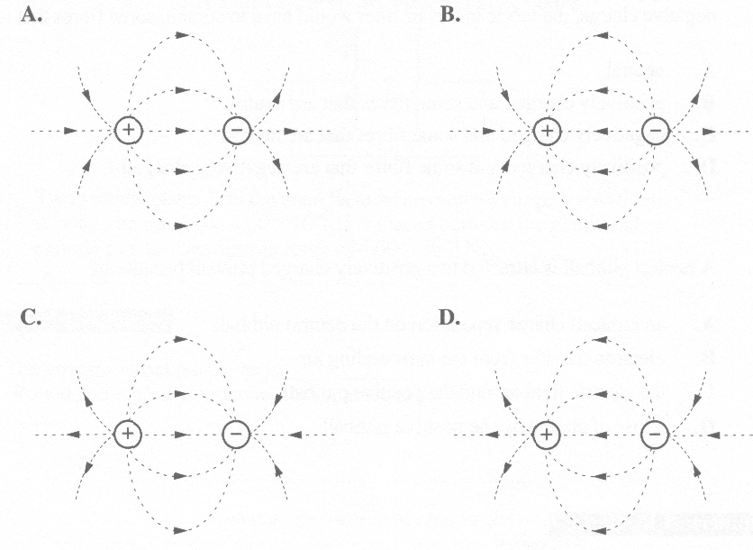

- Two positive charges, q₁ of 2.0 x 10⁻⁶ C and q₂ of 3.0 x 10⁻⁶ C, are separated by 3.0 m. The electric force between them is
A. 2.0 x 10⁻³ N (repulsion)
B. 2.0 x 10⁻³ N (attraction)
C. 6.0 x 10⁻³ N (repulsion)
D. 6.0 x I0⁻³ N (attraction)

- Many asthma cases are due in part to airborne dung pellets from dust mites. A scientist in Britain invented a fabric for use in air filters and carpets that removes the airborne pellets by electrostatic attraction. If the dung pellets are neutral or have a positive or negative charge, the fabric in the air filter would have to contain some fibres that are
A. neutral
B. positively charged and some fibres that are neutral
C. negatively charged and some fibres that are neutral
D. positively charged and some fibres that are negatively charged

- A neutral pithball is attracted to a positively charged pithball because of
A. an induced charge separation on the neutral pithball
B. electron transfer from the surrounding air
C. the electric field around the positive pithball
D. a loss of charge by the positive pithball

Numerical Response

- At a distance 5.06 m from a point charge of magnitude 6.02 x 10⁻⁶ C, the magnitude of the electric field strength is b x 10³ N/C. The value of b is ________.

(Record your three-digit answer in the numerical-response section on the answer sheet.)

- What is the distance between a stationary point charge of 1.20 x 10⁻⁹ C and an alpha particle if the alpha particle initially accelerates at 7.35 x 10⁸ m/s² ?
A. 0.353 m
B. 0.594 m
C. 0.706 m
D. 0.840 m

Use the following information to answer the next question.

A Point Charge between Parallel Plates
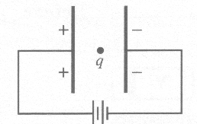
Two vertical plates 2.50 cm apart have an unknown voltage across them. A point charge of q = 3.00 x 10⁻⁶ C is placed between the plates and experiences an electrostatic force of 4.00 x 10⁻⁴ N.

Numerical Response

- The voltage across the plates is __________ V.

(Record your three-digit answer in the numerical-response section on the answer sheet.)

Use the following information to answer the next question.

Resultant Electric Field

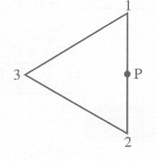
Three equal positive charges are located at the vertices of an equilateral triangle.

- The direction of the electric field at point P is
A. into the page
B. out of the page
C. to the left of the page
D. to the right of the page

Use the following information to answer the next three questions.

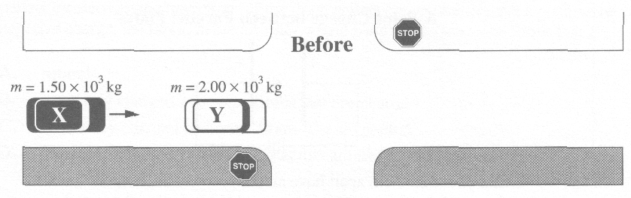
A police officer's investigation of an accident involving a collision between vehicles X and Y provided the following information:

1. a test on the road surface with a 2.00 x 10³ kg vehicle showed that the vehicle slowed down at the rate of 5.00 m/s² due to friction
2. each vehicle, X and Y, received some damage
3. after impact, vehicle Y travelled 19.6 m before stopping
4. vehicle X did not have the brakes applied before the collision
5. vehicle Y was stationary before the collision
6. vehicle X was stationary after the collision
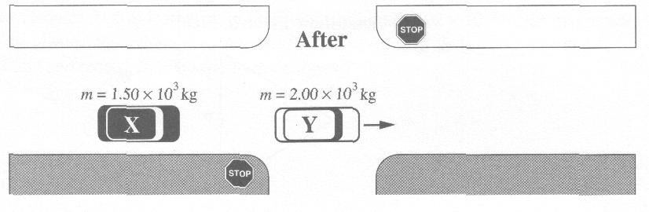

- What was the speed of vehicle Y just after the collision?
A. 19.6 m/s
B. 14.0 m/s
C. 11.0 m/s
D. 1.56 m/s

Use your answer from Multiple Choice 7 to answer Numerical Response 3.

Numerical Response

- Immediately before the collision, the speed of vehicle X was __________ m/s.

(Record your three-digit answer in the numerical-response section on the answer sheet.)

- In analyzing the scene of the accident, the officer most often applied her understanding of
A. Newton's First Law
B. Newton's Second Law
C. the Law of Conservation of Energy
D. the Law of Conservation of Momentum

Use the following information to answer the next question.

Light Circuits
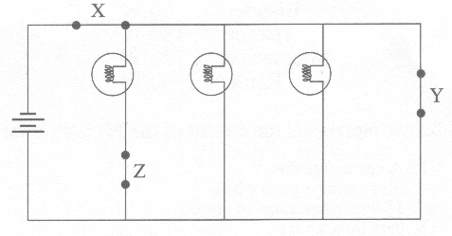

- In order to light all three bulbs in the circuit, the switches at X, Y, and Z, respectively, must be
A. closed, closed, and open
B. closed, closed, and closed
C. closed, open, and closed
D. open, closed, and closed

Use the following information to answer the next question.

Electrical Circuit
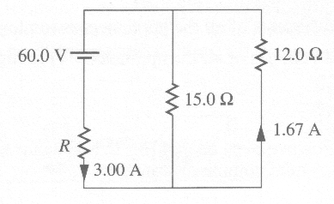
In this circuit, the voltages and currents are as indicated.

Numerical Response

- The current through the 15.0 Ω resistor is ___________ A.

(Record your three-digit answer in the numerical-response section on the answer sheet.)

- In a transformer for a doorbell, 115 V AC is to be stepped down to 24.0 V AC. If the primary coil has 600 turns, how many turns should be on the secondary coil?
A. 125
B. 215
C. 485
D. 2875

Use the following information to answer the next question.

Current Flow in a Wire
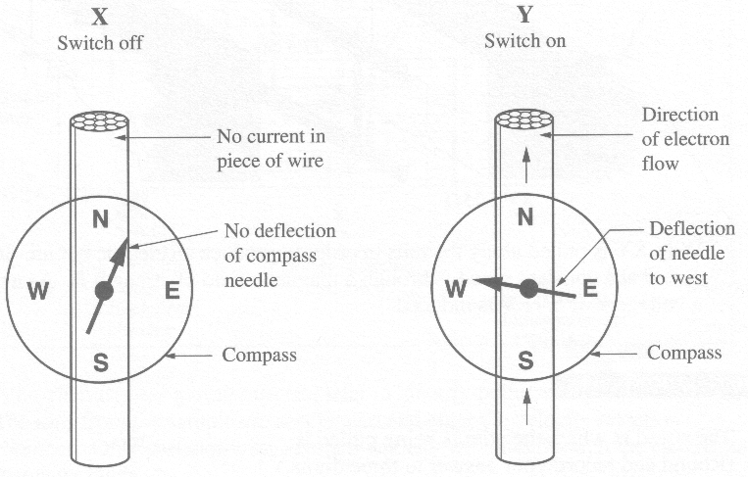

- If the direction of the electron flow in diagram Y is reversed, the compass needle will point
A. north
B. south
C. east
D. west
_____________________________

- Compasses are not used to navigate in the Far North because the
A. magnetic field does not extend to the Far North
B. magnetic field is non-uniform near the Far North
C. magnetic field lines point down to the Earth in the Far North
D. magnetic field lines are parallel to the Earth's surface in the Far North

Use the following information to answer the next two questions.
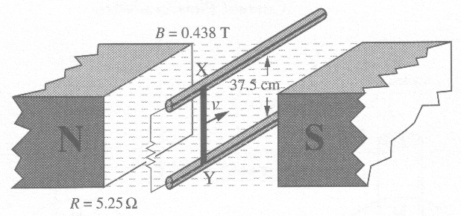
Wire XY is pulled along the rails in order to produce an electric circuit. It is pulled at a constant speed v through a magnetic field of strength B. As a result, a voltage V of 5.41 V is induced.

Numerical Response

- The speed at which the wire is being pulled is _________ m/s.

(Record your three-digit answer in the numerical-response section on the answer sheet.)

Numerical Response

- The applied force on the wire required to induce a constant voltage of 5.41 V, expressed in scientific notation, is b x 10^{-w} N. The value of b is __________.

(Record your three-digit answer in the numerical-response section on the answer sheet.)

Use the following information to answer the next question.

Mass Spectrometer
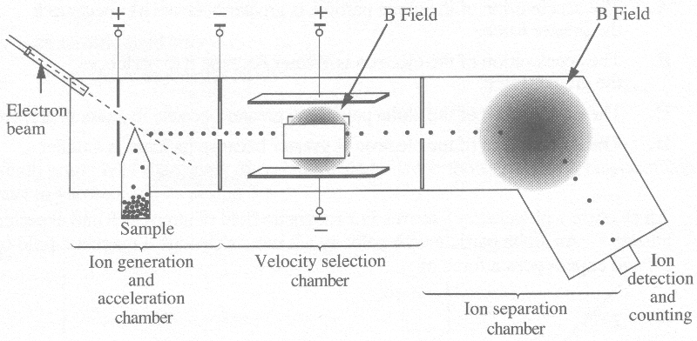
A biochemist uses a mass spectrometer to identify pollutants in a water sample. The ions from the sample are accelerated and enter the velocity selection chamber. Only particles with a certain velocity will pass through the electric and magnetic fields.

- Which derived equation could be used to determine, the speed of the ions as they enter the ion separation chamber?
A. 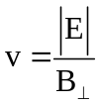
B. 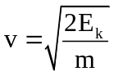
C. 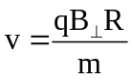
D. 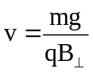

- An alpha particle and an electron traveling at the same speed enter perpendicularly into a uniform magnetic field. Which of the following statements concerning the acceleration of the particles is correct?
A. The acceleration of the alpha particle is greater because it experiences the greater force.
B. The acceleration of the electron is greater because it experiences the greater force.
C. The acceleration of the alpha particle is greater because its mass is greater.
D. The acceleration of the electron is greater because its mass is smaller.

- An electron with velocity v moves in a magnetic field of strength B and experiences a force F. An alpha particle with velocity v/2 moves through a magnetic field of strength 5B and experiences a force of
A. 2F/5
B. 5F/2
C. 5F
D. 10F

- An alpha particle travels in an orbit with a radius of 5.00 cm in a magnetic field of strength 0.80 T. What is the time taken to complete one orbit?
A. 2.60 x 10⁻⁸ s
B. 8.00 x 10⁻⁸ s
C. 1.02 x 10⁻⁷ s
D. 1.63 x 10⁻⁷ s

- A unit combination equivalent to the tesla is
A. 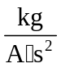
B. 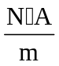
C. 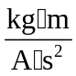
D. 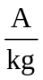

- A stream of neutral atoms in a vacuum produces
A. electromagnetic waves
B. a magnetic field only
C. an electric field only
D. no magnetic or electric fields

- Which graph best represents the relationship between the speed v of an electromagnetic wave in vacuum and its period T?
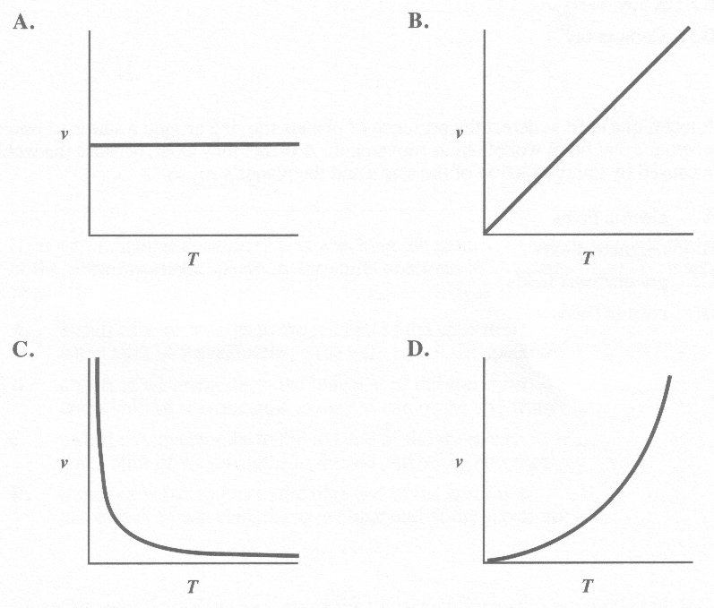

Use the following information to answer the next four questions.

Astronomers believe that one of the best locations for finding planets is in areas of space where new stars are being formed. Because planets do not emit light, they have to be detected by the behaviour of the star.

- Initially, young stars are invisible because they exist at a low temperature. In what portion of the electromagnetic spectrum might astronomers initially attempt to detect a young star?
A. Infrared
B. Ultraviolet
C. X-ray
D. Gamma ray

- A technique used to detect the presence of planets moving around a star is to find out whether a star has a wobble in its movement. A planet may exist, because the wobble is caused by the interaction of the star's and the planet's
A. electric fields
B. magnetic fields
C. gravitational fields
D. cosmic fields

Use this additional information to answer the next two questions.

As a planet moves around a star, the gravitational force of attraction pulls the star away from Position O, as shown in Diagram M. In Diagram N, the star pulls toward Position O.
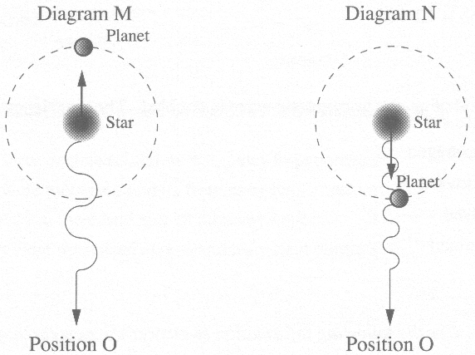

- If an astronomer at Position O was watching the emitted light in the visible portion of the electromagnetic spectrum, the shifts observed in Diagrams M and N, respectively, would be
A. a shift of wavelengths to the red end of the spectrum and a shift of wavelengths to the blue end of the spectrum
B. a shift of wavelengths to the blue end of the spectrum and a shift of wavelengths to the red end of the spectrum
C. a shift of wavelengths to the red end of the spectrum and a shift of wavelengths to the red end of the spectrum
D. a shift of wavelengths to the blue end of the spectrum and a shift of wavelengths to the blue end of the spectrum

- An astronomer finds that the average time it takes for the shift in wavelength from Diagram M to Diagram N is 28 days. From this, the astronomer may conclude that the period for the planet is
A. 28 days
B. 56 days
C. 84 days
D. 112 days

- If the period of an electromagnetic wave is 1.96 x 10⁻¹⁵ s, its wavelength in vacuum is
A. 1.53 x 10²³ m
B. 5.08 x 10¹⁴ m
C. 1.70 x 10⁻⁶ m
D. 5.88 x 10⁻⁷ m

- The period of an electromagnetic wave is doubled. The wavelength is then
A. unchanged
B. quartered
C. halved
D. doubled

Use the following information to answer the next three questions

A Physics Apparatus

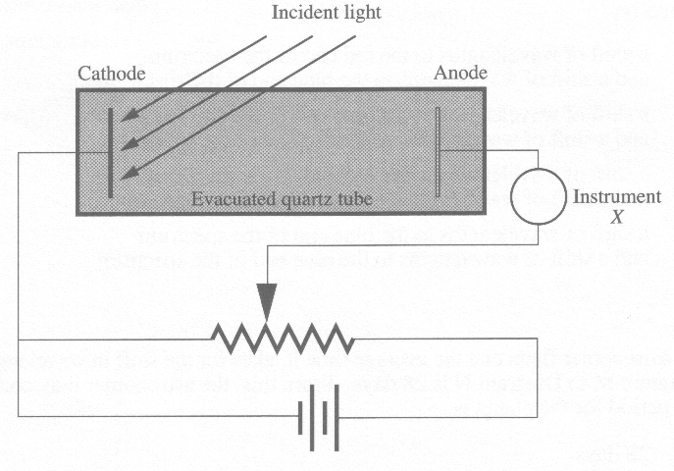

- The apparatus in the illustration would most likely be used to demonstrate the
A. Millikan experiment
B. Photoelectric effect
C. Compton effect
D. Doppler effect

- The reading of instrument X would be increased if the incident light's
A. intensity were decreased and its frequency kept constant
B. intensity were increased and its frequency kept constant
C. frequency were increased and its intensity kept constant
D. frequency were decreased and its intensity kept constant

- Instrument X is most likely
A. an ammeter
B. an ohmmeter
C. a magnetometer
D. a voltmeter

Numerical Response

- A metal has a work function of 1.82 eV. Light with a frequency of 8.31 x 10¹⁴ Hz is incident on the metal. The stopping voltage is __________ V.

(Record your three-digit answer in the numerical-response section on the answer sheet.)

Numerical Response

- The minimum potential difference required by an X-ray tube to produce a wavelength of 7.25 x 10⁻⁹ m, expressed in scientific notation, is b x l0^{w} V. The value of b is ________.

(Record your three-digit answer in the numerical-response section on the answer sheet.)

- X-rays can be classified as
A. high frequency electromagnetic waves
B. long-wavelength radio waves
C. low-energy cathode rays
D. ionized gas particles

- Doctors often use X-ray photographs as diagnostic tools. The property that makes it possible to show broken bones is that X-rays
A. consist of high frequency electromagnetic waves
B. penetrate substances to different depths
C. cannot be deflected by electric and magnetic fields
D. are produced when high energy electrons strike a metal target

Numerical Response

- In a Geiger-Muller tube (a type of radiation detector), electrons are accelerated from rest by a potential difference of 4.05 x 10² V. The speed of the electrons when they strike the collecting anode, in scientific notation, is b x 10⁷ m/s. The value of b is _________.

(Record your three-digit answer in the numerical-response section on the answer sheet.)

- Radium is a radioactive element. Which of the following graphs corresponds to the relationship between the mass of radium that is remaining and time?

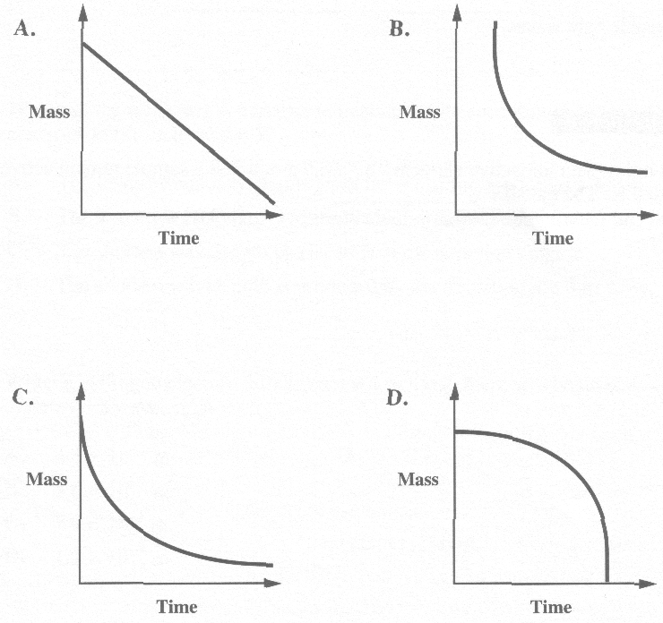

- Some smoke detectors are activated when the current produced by a radioactive source fluctuates. If the activity rate of a radium source is 3.7 x 10⁴ disintegrations/second and each disintegration results in the release of one alpha particle, the effective current produced by the radioactive source is
A. 2.4 x 10⁻¹³ A
B. 1.2 x 10⁻¹⁴ A
C. 6.0 x 10⁻¹⁵ A
D. 5.0 x 10⁻¹⁶ A

- An unstable atomic nucleus releases a photon having an energy of 6.60 x 10⁻¹¹ J. The type of radiation identified with this magnitude of energy is
A. radio waves
B. gamma rays
C. ultraviolet rays
D. visible light waves

Numerical Response

- For an unknown radioactive element "X," 48.0 g of a 768 g sample remain active after 10.2 h. The half-life is _________ h.

(Record your three-digit answer in the numerical-response section on the answer sheet.)

Use the following information to answer the next two questions.

Energy Level Diagram of a Hydrogen Atom
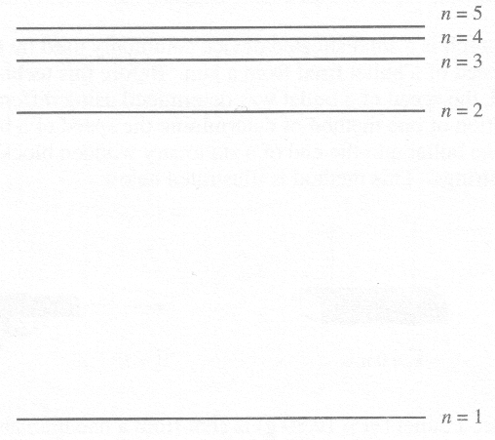

- Which of the following is a true statement about the spectrum produced when hydrogen electrons fall from level n = 5?
A. The lowest frequency results from the transition n = 5 to n = 1.
B. The longest wavelength produced is in the visible region.
C. The shortest wavelength produced is in the ultraviolet region.
D. The shortest wavelength is produced by the transition n = 5 to n = 4.

- When a hydrogen electron falls from n = 4 to n = 2, there will be an emission of a photon of light with wavelength
A. 4.8 x 10⁻⁷ m
B. 3.6 x 10⁻⁷ m
C. 2.9 x 10⁻⁷ m
D. 1.2 x 10⁻⁷ m

Written Response

Use the following information to answer written response question 1 parts a to e.

While studying a radioactive phosphorus 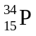, it was discovered that a 128 g sample had decayed to 4.48 g after 60 s. The following table provides data corresponding to the decay.

Mass (g) 128.0 73.0 41.9 23.9 13.7 7.80 4.48
Time (s) 0 10 20 30 40 50 60

1.

(10 marks)
a. On the grid below, graph the data with the manipulated variable on the horizontal axis. Provide a suitable title for your graph.

b. Using your graph, or some other appropriate method, determine the half-life of this substance. Indicate how you determined your answer.

c. When material decays, it emits a particle. An experiment similar to the J. J. Thomson experiment is performed to determine the charge-to-mass ratio of this particle. It is found that the particle moves undeflected through mutually perpendicular magnetic and electric fields of 2.00 x 10⁻³ T and 1.08 x 10⁴ N/C, respectively. When the electric field is turned off, the particle is found to deflect to a radius of 1.53 x 10⁻² m. Using the formula on the data sheets, determine the type of particle emitted. Show all the steps needed to make this determination.

d. Using the section of the periodic table provided below, write the decay equation for the decay in part c, identifying the product isotope. (If you were not able to answer part c, assume an alpha decay.)

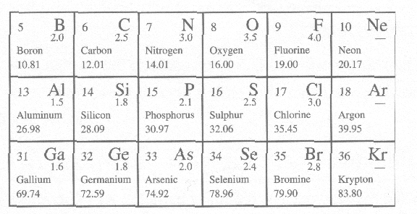

e. How would a gamma ray have been affected by passage through a magnetic field as mentioned in part c?

